Eclipse IDE for Java EE Developers
Go to http://www.eclipse.org/downloads/. Look for the Galileo Packages (based on Eclipse 3.5 SR2)
Click on this link: Eclipse IDE for Java EE Developers . From the Eclipse downloads page, download eclipse-jee-galileo-SR2-win32.zip into your PC.
For e.g. extract the zip file in C:\installers\eclipse-jee-galileo-SR2-win32
Eclipse installation folder would be - C:\installers\eclipse-jee-galileo-SR2-win32\eclipse

Adobe Flash Builder 4 Eclipse Plug-in
Download or copy the Flash Builder 4 plug-in bundle and install to your PC. While installing this plug-in, make sure to choose the option to use the local eclipse IDE that you have on your PC, this way the plug-in would be integrated with your local eclipse IDE.

SCME plug-in for eclipse

http://wiki.web.att.com/display/GSCMTeam/SCME+Download
see below, look for Eclipse Plug-in Releases, Scmeplugin_2.0.0.jar, download this jar into your eclipse plugins folder, follow the installation notes.

Below “Installing” steps might be accurate

With this plug-in you can create MRs and perform edits against source stored in a SCME database.
To download the plug-in, ver. 1.0.9, refer the Software Configuration Management –SCME Downloads page: http://scm.sbc.com/midrange_scme_download.html
The SCME download page points to Client Install Notes: http://scm.sbc.com/opencms/export/sites/default/scm/docs/client-eclipse1X.doc
SCME plugin for Eclipse: http://scm.it.att.com/midrange_scme.html
Copy the SCME plug-in (Scmeplugin_1.0.9.jar file) into the eclipse plugins folder. Restart eclipse if already started or launch eclipse freshly. This should complete the SCME plug-in installation for eclipse.
Note: Pre-requisite for SCME configuration in eclipse is to set up a SSH public key authentication mechanism for the client PC. Authentication to the SCME host from the PC should be setup without Unix login, i.e. through public key mechanism. Please refer to the instructions in next section.
Setting up SSH key-based authentication between PC and SCME Unix host
Install a key generation utility like puttygen.exe in your PC.
Launch puttygen, push the Generate button, this would generate public and private keys. Copy the public key string that appears in the Key text area into a text pad. This public key string should be copied later into the user’s $HOME/.ssh/authorized_keys file in SCME host. Enter a Key passphrase to generate a private key.
Note: The key passphrase is very important and should be remembered. This passphrase would be required later for SCME configuration in eclipse.
Save the public and private key files in your PC. For e.g. rp5662.pub and rp5662_pk.ppk
In puttygen, click the Conversions menu option -> choose Export OpenSSH key option from the list, save this key in the same folder as public and private key files. This key is required for eclipse SCME configuration. For e.g. save as rp5662_eclipse.ppk
Create a .ssh directory in your unix HOME directory if it does not exist. Create the authorized_keys file under .ssh directory. Copy the public key string into authorized_keys file, save and exit the file.
Note: Please make sure that the public key is stored as-is and without any modifications.
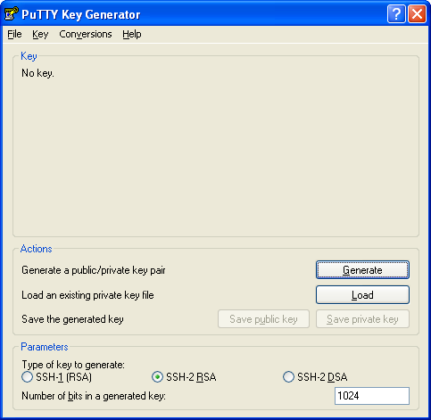
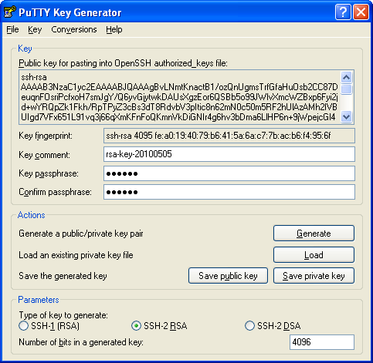
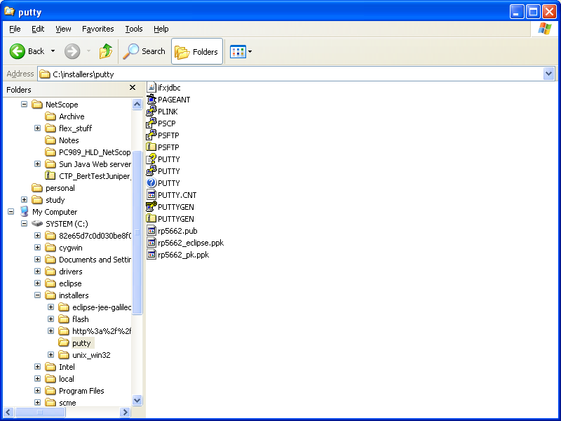

Create a SSH connection profile in putty
Launch putty, specify the SSH connection details for the SCME host, save the session as shown in the example below.
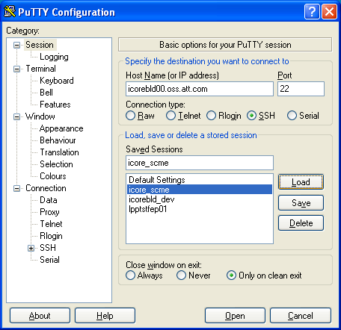
Expand the SSH option tree, select the Auth attribute, in the SSH authentication screen, browse and locate the private key file location containing the SSH private key that we created previously.
Open the SSH connection using this saved session. You will be prompted to login with your unix user ID and passphrase. Enter the passphrase that was used to create private key. This would complete the authentication process and you can login to the SCME host through key-based authentication using putty.
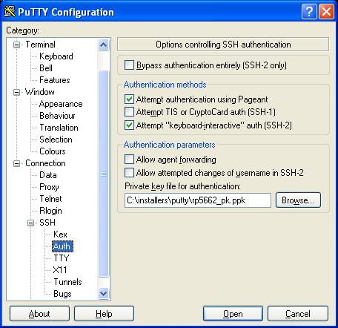
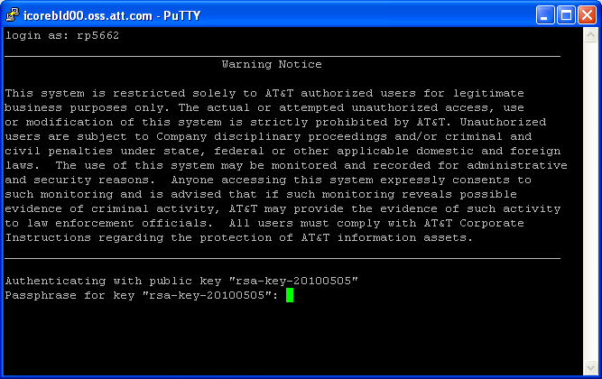

SCME configuration for Eclipse projects
In eclipse IDE, right click on any project and choose the option: Scme -> Configuration Wizard , this should open the screen for Scme Host Page. Fill in the details as shown in the image below. Push the Verify Connection button to check if authentication works from eclipse to SCME host.
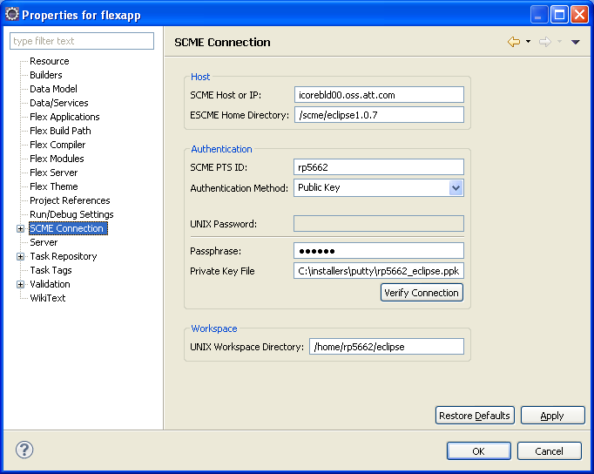
Next, in the Product Generic screen, choose the product name and generic [ntscp, netscope2010.3]. This should complete the SCME configuration for that eclipse project, repeat this procedure for other eclipse projects in your workspace if required.
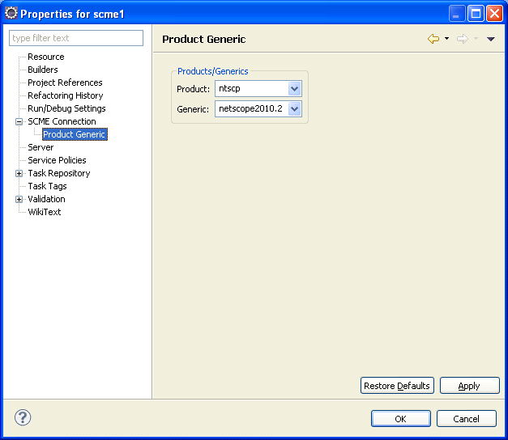
Verify that the scme commands are available from your eclipse workspace.
